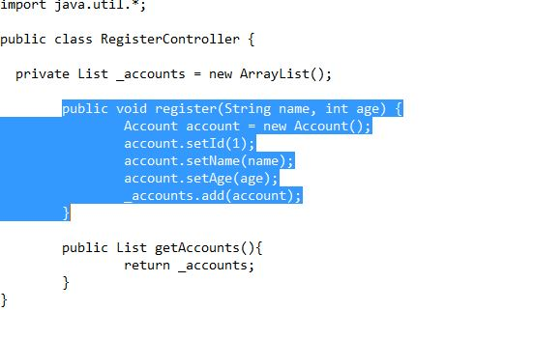**Quiz#4 (Draw Sequence diagram)**

**Use case:** Get register

**Solution:**

